Practical no 4
Code:-
print("==TRAFFIC SIGNAL STIMULATION===")
signal=input("Enter traffic signal colour:").lower()
if signal=="red":
print("Action:STOP")
elif signal=="yellow":
print("Action:WAIT")
elif signal=="green":
print("Action:GO")
else:
print("invalid signal")
Output:-
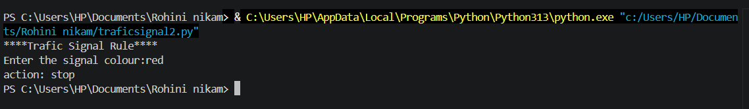

Exercises
Q1.Develop an automated order –tracking simulation system that takes a status keyword (eg. “shipped”,delivered”,pending”) and output a customized logistics tracking update message.
status=input("Enter your order status(shipped/delivered/shiping):").lower()
if status == "shipped":
print("Your orded has been shipped and is on its way...")
elif status == "delivered":
print("Your ordered has been delivered successfully...")
elif status == "pending":
print("Your ordered is pending and will be processed soon...")
else:
print("Invalid status. Please enter shiped , delevered, or Pending")
Output:-
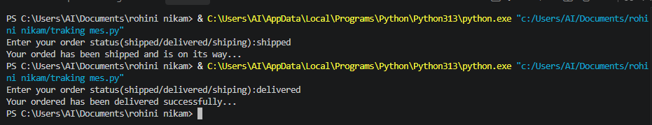

Q 2.Build a basic smart –home climate monitoring script that reads an atmospheric status string and print out hardware recommendations (eg.turn on ac ,activate heater, idle).
Code:-
status=input("Enter atmospheric status(hot, cold, normal) :").lower()

if status == "hot":
print("Recommendation : Turn on AC .")
elif status == "cold":
print("Recommendation : Active heater.")
elif status == "normal":
print("Recommendation : Keep the system idle.")
else :
print("Invalid atmosphereic status.")
Output:-
